

DUNDALK INSTITUTE OF TECHNOLOGY
School of Informatics & Creative Arts
Ethical Approval Form for Research Projects

Researcher Name: Yahya Angawi, Kingsley Osemwenkhae & Roisin McPhillips Year: 2022 Course: Computing in Software Development

Title of project: Dash Warning

Name of supervisor/s __Enda Finn________________________ Date ____21/2/2022_______
(if applicable)

This application is to be completed by the researcher and where appropriate, in conjunction with the project supervisor. The lead researcher/supervisor is responsible for submitting the completed form to the appropriate Research Ethics Committee (details below)

Please note: If your submission is incomplete or unclear, your application will be returned to you and your project may be delayed.

Section 1
Type of Researcher

Please tick the appropriate box below to indicate the type of researcher you are:

Undergraduate
X
(proceed to section 2)

Completed Ethical Approval forms for undergraduate research should be submitted to the relevant Departmental Research Ethics Committee (DREC).

Drec.dcamm@dkit.ie – Department of Creative Arts Media and Music
Drec.dcsm@dkit.ie – Department of Computing Science and Mathematics
Drec.dvhcc@dkit.ie – Department of Visual and Human Centred Computing

Postgraduate

(proceed to section 3)

Completed Ethical Approval forms for Postgraduate research should be submitted directly to the School Research Ethics Committee (SREC).

Srec.ica@dkit.ie

Staff

(proceed to section 3)

Completed Ethical Approval forms for Staff research should be submitted directly to the School Research Ethics Committee (SREC).

Srec.ica@dkit.ie
Section 2

Please complete questions 1-4 listed below.

 | Human and / or Animal Research | YES | NO
1 | Does your research involve human participants other than the following?  - Research using exclusively secondary sources.  - Research using materials legally accessible to the public that have legal protection, e.g., record of court judgements, data archives.  - Research using materials that are publicly accessible and where there is no reasonable expectation for privacy, e.g., books, published third party interviews.  - Observations of human behavior in public where (i) those being observed have no reasonable expectation of privacy, (ii) there is no intervention on the part of the researcher nor any interaction between the researcher and those observed, and (iii) individuals are not identifiable in the results.  If ‘YES’, please complete B and C below. | X
2 | Does your project involve working with animals?  – If ‘YES’, please complete B and C below. – Please note that for ethical consideration: ‘Animals’ are classed as vertebrate animals including cyclostomes and cephalopods (DIRECTIVE 2010/63/EU) |  | X
3 | Does your project involve working with participants from any of the following categories?  - Minors (under 18 years of age)  - People with learning or communication difficulties  - Patients  - People in custody  - People engaged in illegal activities  If ‘YES’, please complete D below. |  | X
4 | Does your project have any possible ethical implications other than those outlined in questions 1, 2 and 3?  If ‘YES’, please complete E below. |  | X

- I consider that this project has no significant ethical implications to be brought through the ICA School Ethics Review Process
X
Please complete Section 4

  - Is this study part of a larger project that already has ethical clearance?

YES / NO

If YES please answer question B II.
If NO please answer question C.

  - If this study is part of a larger project that already has ethical clearance, are you proposing any changes to the operational plan already ethically approved?

YES / NO

If YES, please complete Sections 3 and 4.
If NO, then please provide the project details below and complete Section 4.

Title of project with ethical clearance: _____________________________________

- Could this project have ethical implications that should be brought before the appropriate ICA Departmental Ethics Review Committee as it will be carried out with human participants?

YES / NO

If YES, please complete Sections 3 and 4.
If NO, please complete Section 4.

- I consider that this project may have ethical implications that should be brought before the School Research Ethics Committee as it will be carried out with human participants in a “vulnerable” category.

Please complete Sections 3 and 4

All research carried out with human participants in a vulnerable category must be referred by the Departmental Research Ethics Committee to the School Research Ethics Committee for approval.

- Could this project have ethical implications, other than those previously outlined, that should be brought before the appropriate ICA Departmental Ethics Review Committee?

YES / NO

If YES, please complete Sections 3 and 4.
If NO, please complete Section 4.

Section 3

3.1 Application Form Checklist

Please complete Section 3 and provide additional information as attachments.

My application includes the following documentation: | INCLUDED (mark as YES) | NOT APPLICABLE (mark as N/A)
Recruitment advertisement |  | N/A
Participant Information Leaflet | Yes
Participant Informed Consent form | Yes
Questionnaire/Survey |  | N/A
Interview/Focus Group Questions | Yes
Debriefing material |  | N/A
Evidence of approval to gain access to off-site location |  | N/A
Ethical approval from external organizations.  If ethical approval from external organizations is pending give details below |  | N/A
Details

3.2 Project Details

- Lay description (Maximum 200 words)
Please outline, in terms that any non-expert would understand, what your research project is about, including what participants will be required to do. Please explain any technical terms or discipline-specific phrases.
We are team AutoTek, and this is our Collaborative Project Team for Dash Warning application. Dash Warning allows users to scan the symbols that appear on their vehicle's dashboard and displays what each symbol means. Apart from that, it shows or recommends nearby repair shops in situations when a mechanic is needed. The app will also recommend phone numbers to various roadside assistance personals as the users request when their car broken down. The target audience will be everyone who drives a car regardless of if it is new or used focusing on drives of Toyota and Volkswagen. The application also has a facial recognition functionality that is used as an alternative method to login into the application. To use this functionality, we need to store the image of the user’s face. Another functionality is GPS tracking system that will be placed in the car for the user to track the car in case of the car was stolen or the user forgot where they parked the car. The GPS coordinates will not be stored, just displayed. As the user will also need to register for the app and login their details will be saved.
In the user testing phase, participants will be asked to test the following:
- The User interface (UI) of the application to see whether it is easy and intuitive or not.
- The different functionalities such as facial recognition, drowsiness detection, and GPS tracking system.
- Using the Login / Registration of the system.

- Research objectives (Maximum 150 words)
Please summarise briefly the objectives of the research.
The research is done for testing purposes. We want to test whether the application is easy to use and whether the interface and design are intuitive enough. We also want to test the usability of the application and how well it works. We also want to test the application to see if it gives accurate feedback in terms of dash faults and descriptions and to not stress people out.

Furthermore, we need to test the usability of facial recognition and drowsiness detection functionalities. These two functionalities use the raspberry pi that contains a camera. Therefore, we will need to test the best practice to use the camera regarding of the position, lighting, usage, etc. To carry out the facial recognition we will need to ask and store photos of the participants’ faces. We also will be asking the participants to test the GPS tracking system which track a car, not the user. GPS tracking system functionality will not store the coordinates, just display it.

We also need to test the scanner functionality to ensure the app can scan a dashboard fault images, process it and then display the relevant information to the user. This will need to be tested a few times to ensure it is working correctly in good lighting, bad lighting, on newer cars and older cars.

- Research location and duration
Location(s)/Population* | DkIT campus
Research start date | March 2022
Research end date | June 2022
Approximate duration | 10-15 minutes
* If location/Population other than DkIT campus/population, provide details of the approval to gain access to that location/population as an appendix.

3.3 Participants

 |  | YES | NO | N/A
Do participants fall into any of the following special groups? | Minors (under 18 years of age) |  | X
 | People with learning or communication difficulties |  | X
 | Patients |  | X
 | People in custody |  | X
 | People engaged in illegal activities (e.g. drug-taking) |  | X
Have you given due consideration to the need for satisfactory Garda clearance? |  |  |  | X

3.4 Sample Details

Approximate number | 6-10
Where will participants be recruited from? | DkIT campus, Family Members & Partnership
Inclusion Criteria | Students, maybe lecturers, Parents, Mechanic
Exclusion Criteria | Minors, Patients, People in custody, People engaged in illegal activities
Will participants be remunerated, and if so in what form?
NO

Justification for proposed sample size and for selecting a specific gender, age, or any other group if this is done in your research.
This is to test the ease of usability of the application and said functionality.

3.5 Risk to Participants

a) Please describe any risks to participants that may arise due to the research. Such risks could include physical stress, emotional distress, perceived coercion e.g. lecturer interviewing own students. Detail the measures and considerations you have put in place to minimize these risks
b) What will you communicate to participants about any identified risks? Will any information be withheld from them about the research purpose or procedure? If so, please justify this decision.

3.6 Informed Consent

 | YES | NO | N/A
Will you obtain active consent for participation? | X
Will you describe the main experimental procedures to participants in advance? | X
Will you inform the participants that their participation is voluntary and may be withdrawn at any point? | X
If the research is observational, will you ask for their consent to being observed? | X
With questionnaires, will you give participants the option of omitting questions they do not want to answer? | X
Will you tell participants that their data will be treated with full confidentiality and that, if published, it will not be identifiable as theirs? | X
Will the data be anonymous? |  |  | X
Will you debrief participants at the end of their participation? | X
Will your project involve deliberately misleading participants in any way, or will information be withheld?  If you answer yes, give details and justification for doing this below. |  | X

- Please outline your approach to ensuring the confidentiality of data (that is, that the data will only be accessible to agreed upon parties and the safeguarding mechanisms you will put in place to achieve this.) You should include details on how and where the data will be stored, and who will have access to it.
Data will not be shared to third parties except in an exceptional situation by law. And it will be encrypted and transmitted through secure means.
Any data collected for acceptance tests will be kept private and only be used for updating purposes.

- Please outline how long the data will be retained for if it will be destroyed and how it will be destroyed.
- Storage Cloud Services (AWS) / File System on Laptop (Private Folder)

- Access User’s account, using username & password, Acceptance tests done in person by user accessed on laptop (UI /User Stores).

- Communication Through Secure Protocol (HTTPS), In Person Communication

- Digital Platform Usage N/A

- Data maintenance Any data relevant to participants will be deleted after testing. For acceptance test carried out data will be stored privately on laptop for updates to UI and User Stories. Any personal data will be deleted.

Section 4

Researcher I have read, and I understand the DkIT Ethics Policy available from:
https://www.dkit.ie/assets/uploads/documents/Research/Policies/DkIT%20Research%20Ethics%20Policy.pdf

Signed: _Yahya Angawi, Kingsley Osemwenkhae & Roisin McPhillips

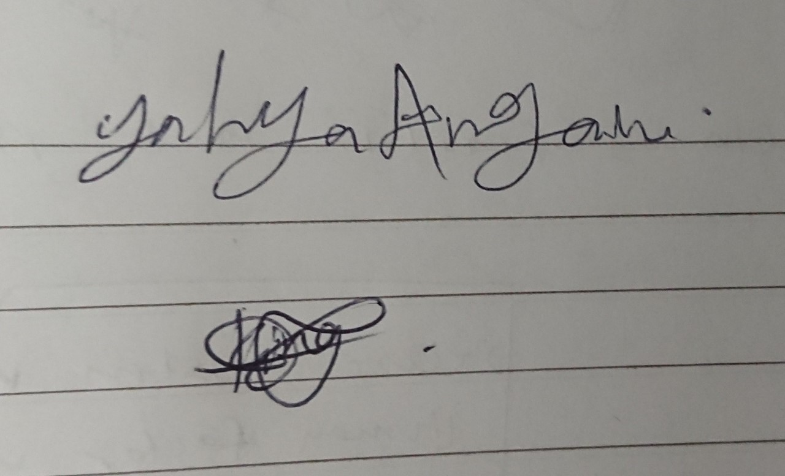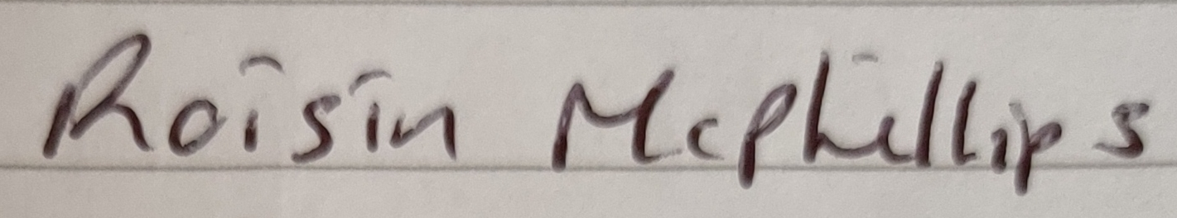

Print Name: Yahya Angawi, Kingsley Osemwenkhae & Roisin McPhillips Date: 2022
(Researcher)

Supervisor: Applications for Ethical Approval of Undergraduate projects are forwarded to the Departmental Research Ethics Committee for approval or referral to the School Research Ethics Committee. Applications for Ethical Approval of Postgraduate and Staff projects are sent to the School Research Ethics Committee for Approval.

I have read and approved this form & information:

Signed: _______________________ Print Name: _______________________ Date: __________
(Supervisor/Head of Department/ Research Centre Director/ Head of School)

There is an obligation on the researcher and/or supervisor to bring to the attention of the Departmental/School Research Ethics Committee(s): (a) Any issues with ethical implications not clearly covered by this form (b) Any ethical issues which may arise during the carrying out of the research; (c) Any ethically significant change made to the project after approval.

Section 5 (For office use only)

----------------------------------------------------------------------------------------------------------------------------

STATEMENT OF ETHICAL APPROVAL (FOR UNDERGRADUATE PROJECTS ONLY)

This project has been considered using agreed department procedures and is now:

Approved:

Referred to the School Ethics Committee:

Signed: _______________________ Print Name: _______________________ Date: __________
(Chair of Departmental Research Ethics Committee/Head of Department)

----------------------------------------------------------------------------------------------------------------------------

STATEMENT OF ETHICAL APPROVAL

This project has been considered using agreed School procedures and is now:

Approved:

Rejected (further information sought):

Chair of School Research Ethics Committee
This project has been considered by the Ethics Committee and ethical approval is granted.

Signed: Print Name: _______________________ Date: __________
Chair of School Research Ethics Committee

If there is any doubt, researchers should contact the Chair of the SREC.
In determining significant implications, please consider all potential risks attached to this project. If there is any doubt, researchers should contact the Chair of the SREC.

